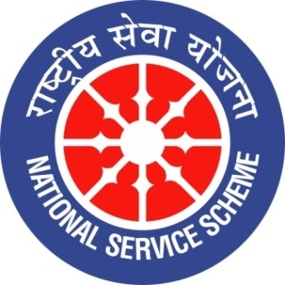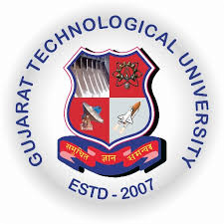
College Logo
GUJARAT TECHNOLOGY UNIVERSITY
NATIONAL SERVICE SCHEME
R N G PATEL INSTITUTE OF TECHNOLOGY
A Report on Art and Science of Manifestations on 06/08/2026 of 084/ R N G Patel Institute of Technology

NSS Unit Name/College Name: R N G Patel Institute of Technology
Event NAME: Magic Memory
Event Date, Time and Location: RNGPIT, Tajpore College, Bardoli, 06 August 2026 at 10:00 AM
Brief Description of the Event
A Magic Memory event was organised on 6 August 2026 at the RNGPIT Auditorium, with Mr. Milan Shah as the speaker. The programme focused on developing memory, concentration, observation, and learning skills through interesting and interactive techniques. Mr. Shah demonstrated various practical methods to improve the ability to remember and recall information effectively. The session was engaging and encouraged active participation from the students. Through demonstrations and activities, participants gained an understanding of how memory can be strengthened through regular practice, proper techniques, and focused attention. The event provided an informative and enjoyable learning experience for all participants.
The event provided several valuable benefits to the participants. It helped students understand practical techniques for improving concentration, memory retention, observation, and recall. The activities encouraged participants to think actively and develop greater mental alertness and confidence. The techniques demonstrated during the session can be applied in academic studies, examinations, presentations, and everyday activities. Students also learned the importance of attention and regular practice in developing stronger memory skills. Overall, the programme motivated participants to improve their learning abilities and adopt more effective study practices. The interactive session by Mr. Milan Shah made the learning experience meaningful, engaging, and beneficial for the participants.

